**Naan Mudhalvan Project**

COLLEGE NAME: Alagappa Govt Arts college

PLACE  : KARAIKUDI

DEPARTMENT  : B.COM

PROJECT NAME: Edu Connect Learning center

Our Team Member

K.NIDHYA SHRI

R.NITHYA

M.MUTHUMEENA

M.NASRIN BANU

**PROJECT REPORT TEMPLATE**

1 INTRODUCTION

1.1 Overview

A brief description about your project

VOLTE

The use of this project. What can be achieved using this.

2 Problem Definition & Design Thinking

1.2 Purpose

2.1 Empathy Map

Paste the empathy map screenshot

2.2 Ideation & Brainstorming Map

Paste the Ideation & brainstorming map screenshot

3 RESULT

Final findings (Output) of the project along with screenshots.

4 ADVANTAGES & DISADVANTAGES

List of advantages and disadvantages of the proposed solution

5 APPLICATIONS

The areas where this solution can be applied

6 CONCLUSION

Conclusion summarizing the entire work and findings.

7 FUTURE SCOPE

Enhancements that can be made in the future.

8 APPENDIX

A. Source Code

Attach the code for the solution built.

**INTRODUCTION**

1.1 Overview

Learning Center Overview

A learning center, often referred to as an educational or resource center, is a physical or virtual space where individuals can access educational materials, resources, and guidance to support their learning and development. These centers can vary widely in terms of their focus and offerings, but here's an overview:

Purpose: Learning centers exist to facilitate and enhance the learning process. They provide a structured and supportive environment for individuals to acquire new knowledge and skills.

Academic Learning Centers: These are often found on college and university campuses and offer tutoring, academic advising, and study resources.

Early Childhood Learning Centers: Designed for young children, these centers provide a foundation for future learning and development.

Adult Education Centers: These centers offer courses, workshops, and resources for adults looking to further their education or acquire new skills.

Online Learning Platforms: Many online platforms serve as virtual learning centers, providing a wide range of courses and resources.

**Key Features**:

Resources: Learning centers typically offer access to books, digital materials, computers, and other learning resources.

Support: Trained staff or volunteers often provide guidance, tutoring, and mentoring.

Workshops and Courses: They may offer structured classes or workshops on various topics.

Accessibility: Learning centers aim to be accessible to a wide range of learners, including those with diverse needs.

**Benefits**:

Individualized Learning: Learning centers can cater to individual needs and learning styles.

Skill Development: They help individuals acquire specific skills or knowledge.

Community and Support: Many learning centers foster a sense of community and provide emotional and academic support.

***2 Problem Definition and Design Thinking***

***2.2 Empathy Map***

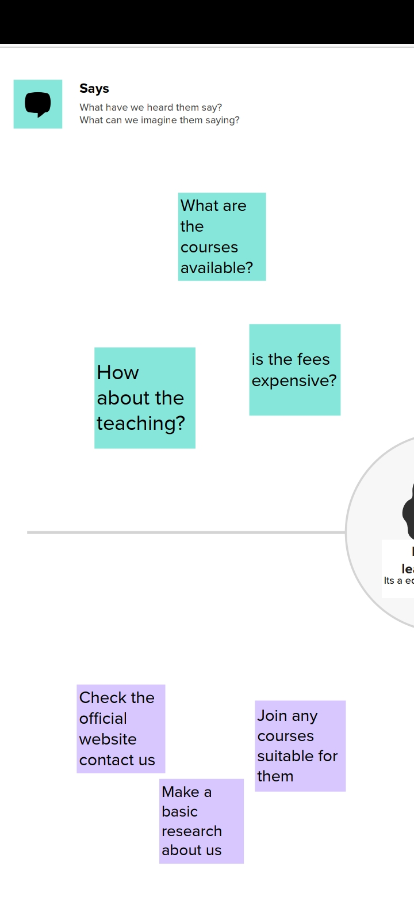

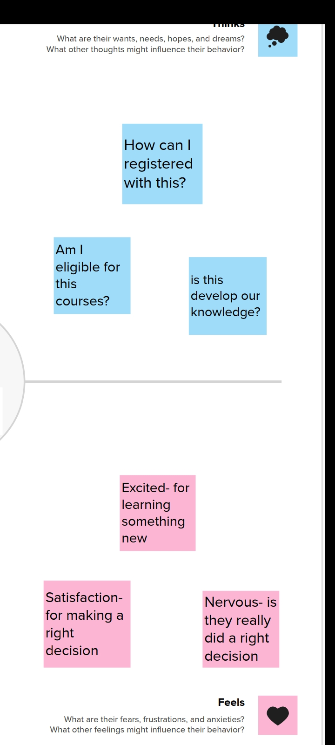

**2.2IDEATION AND BRAINSTORMING**

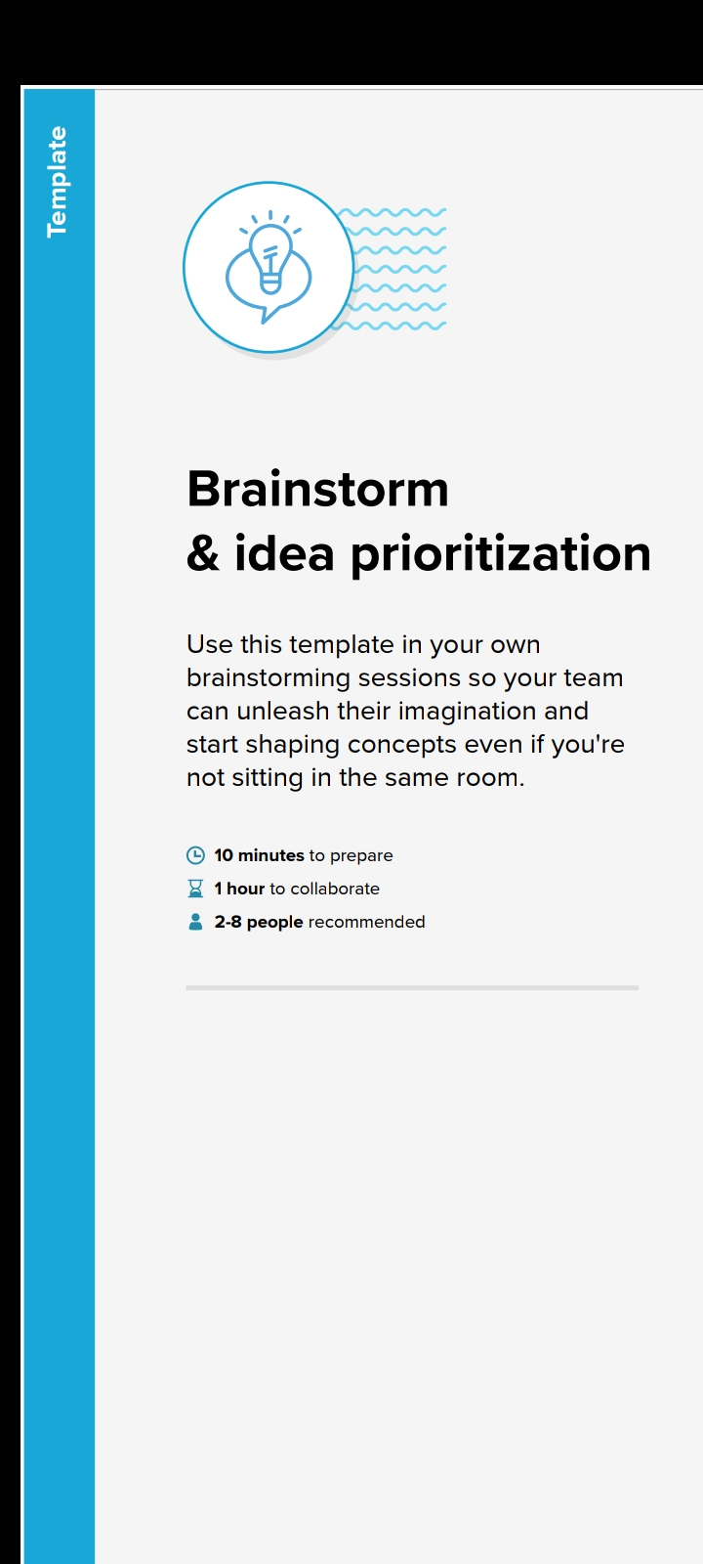



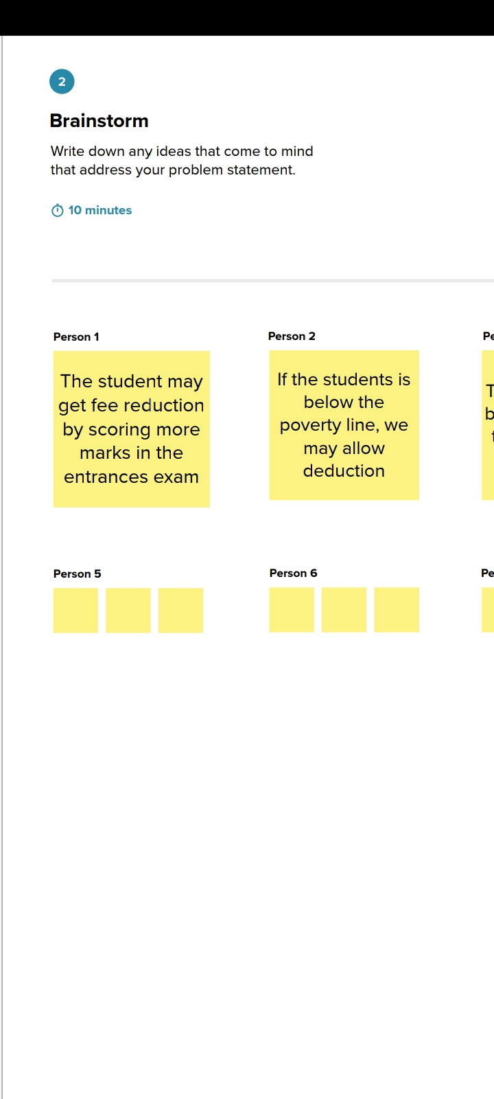

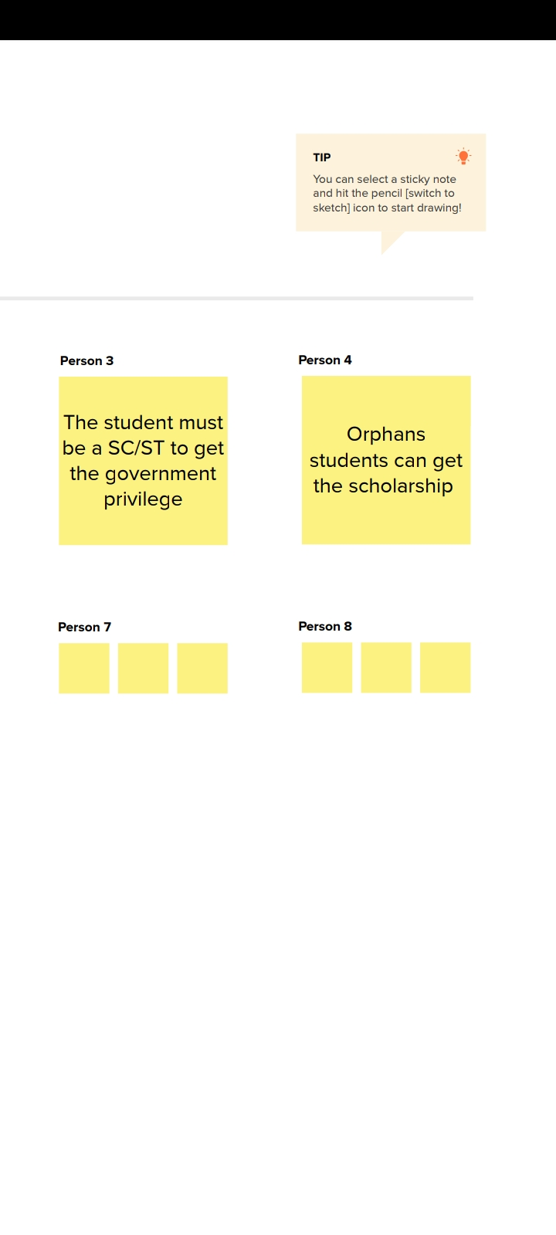

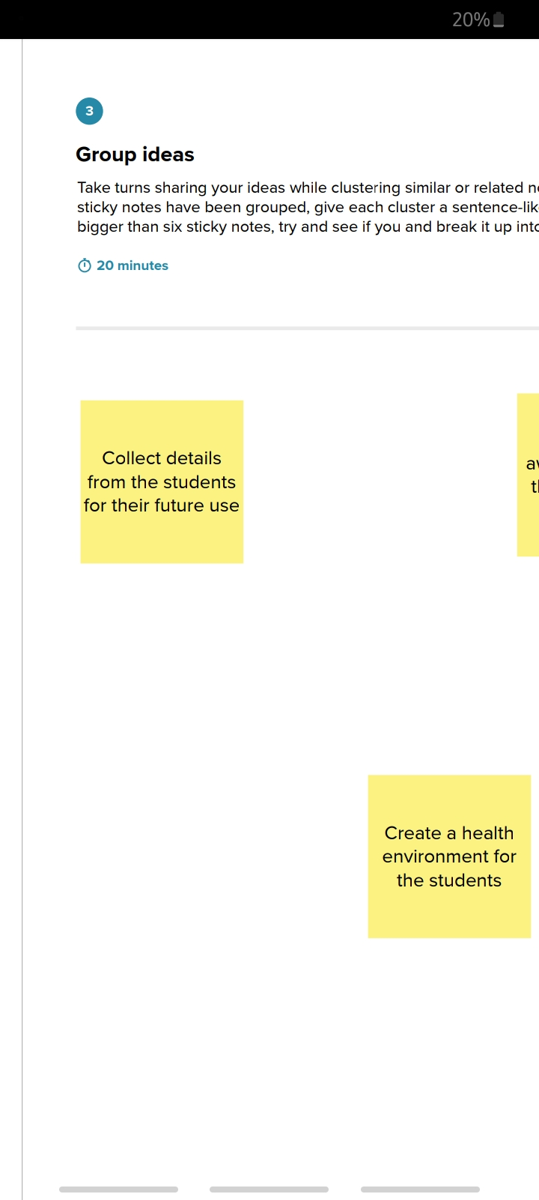

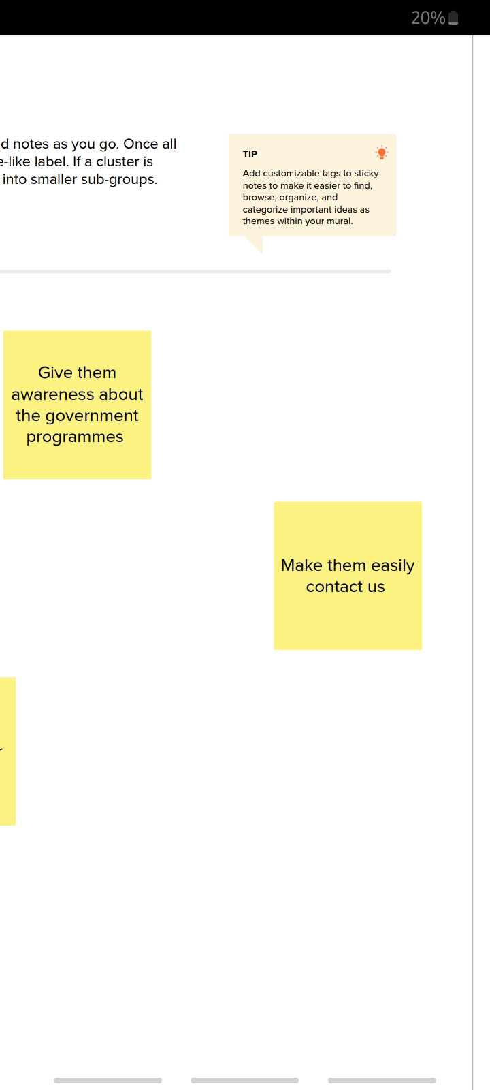

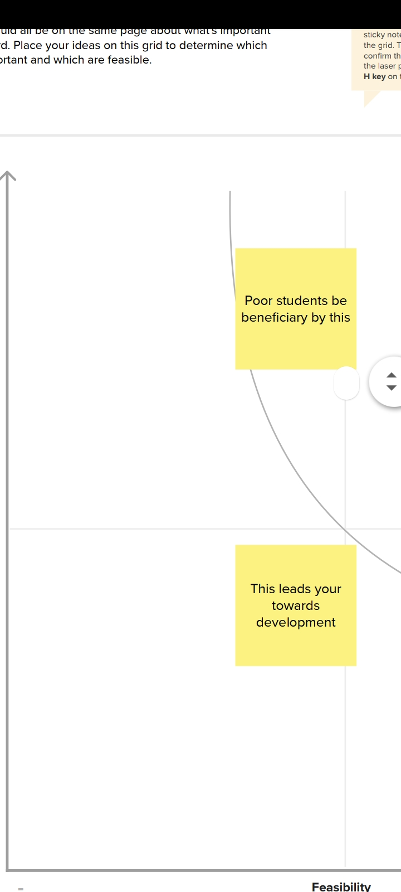

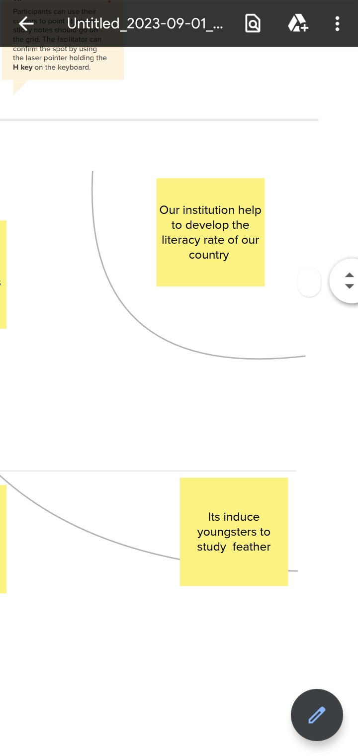

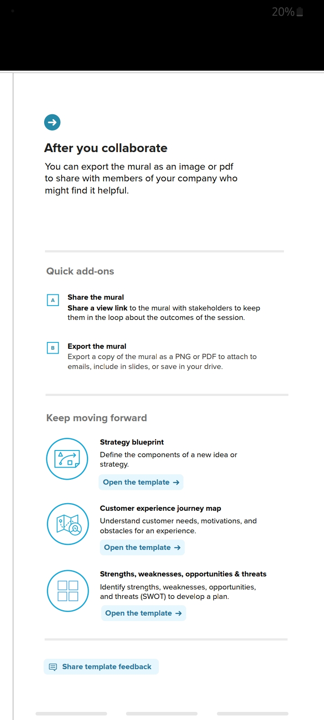

***BALANCE SHEET***

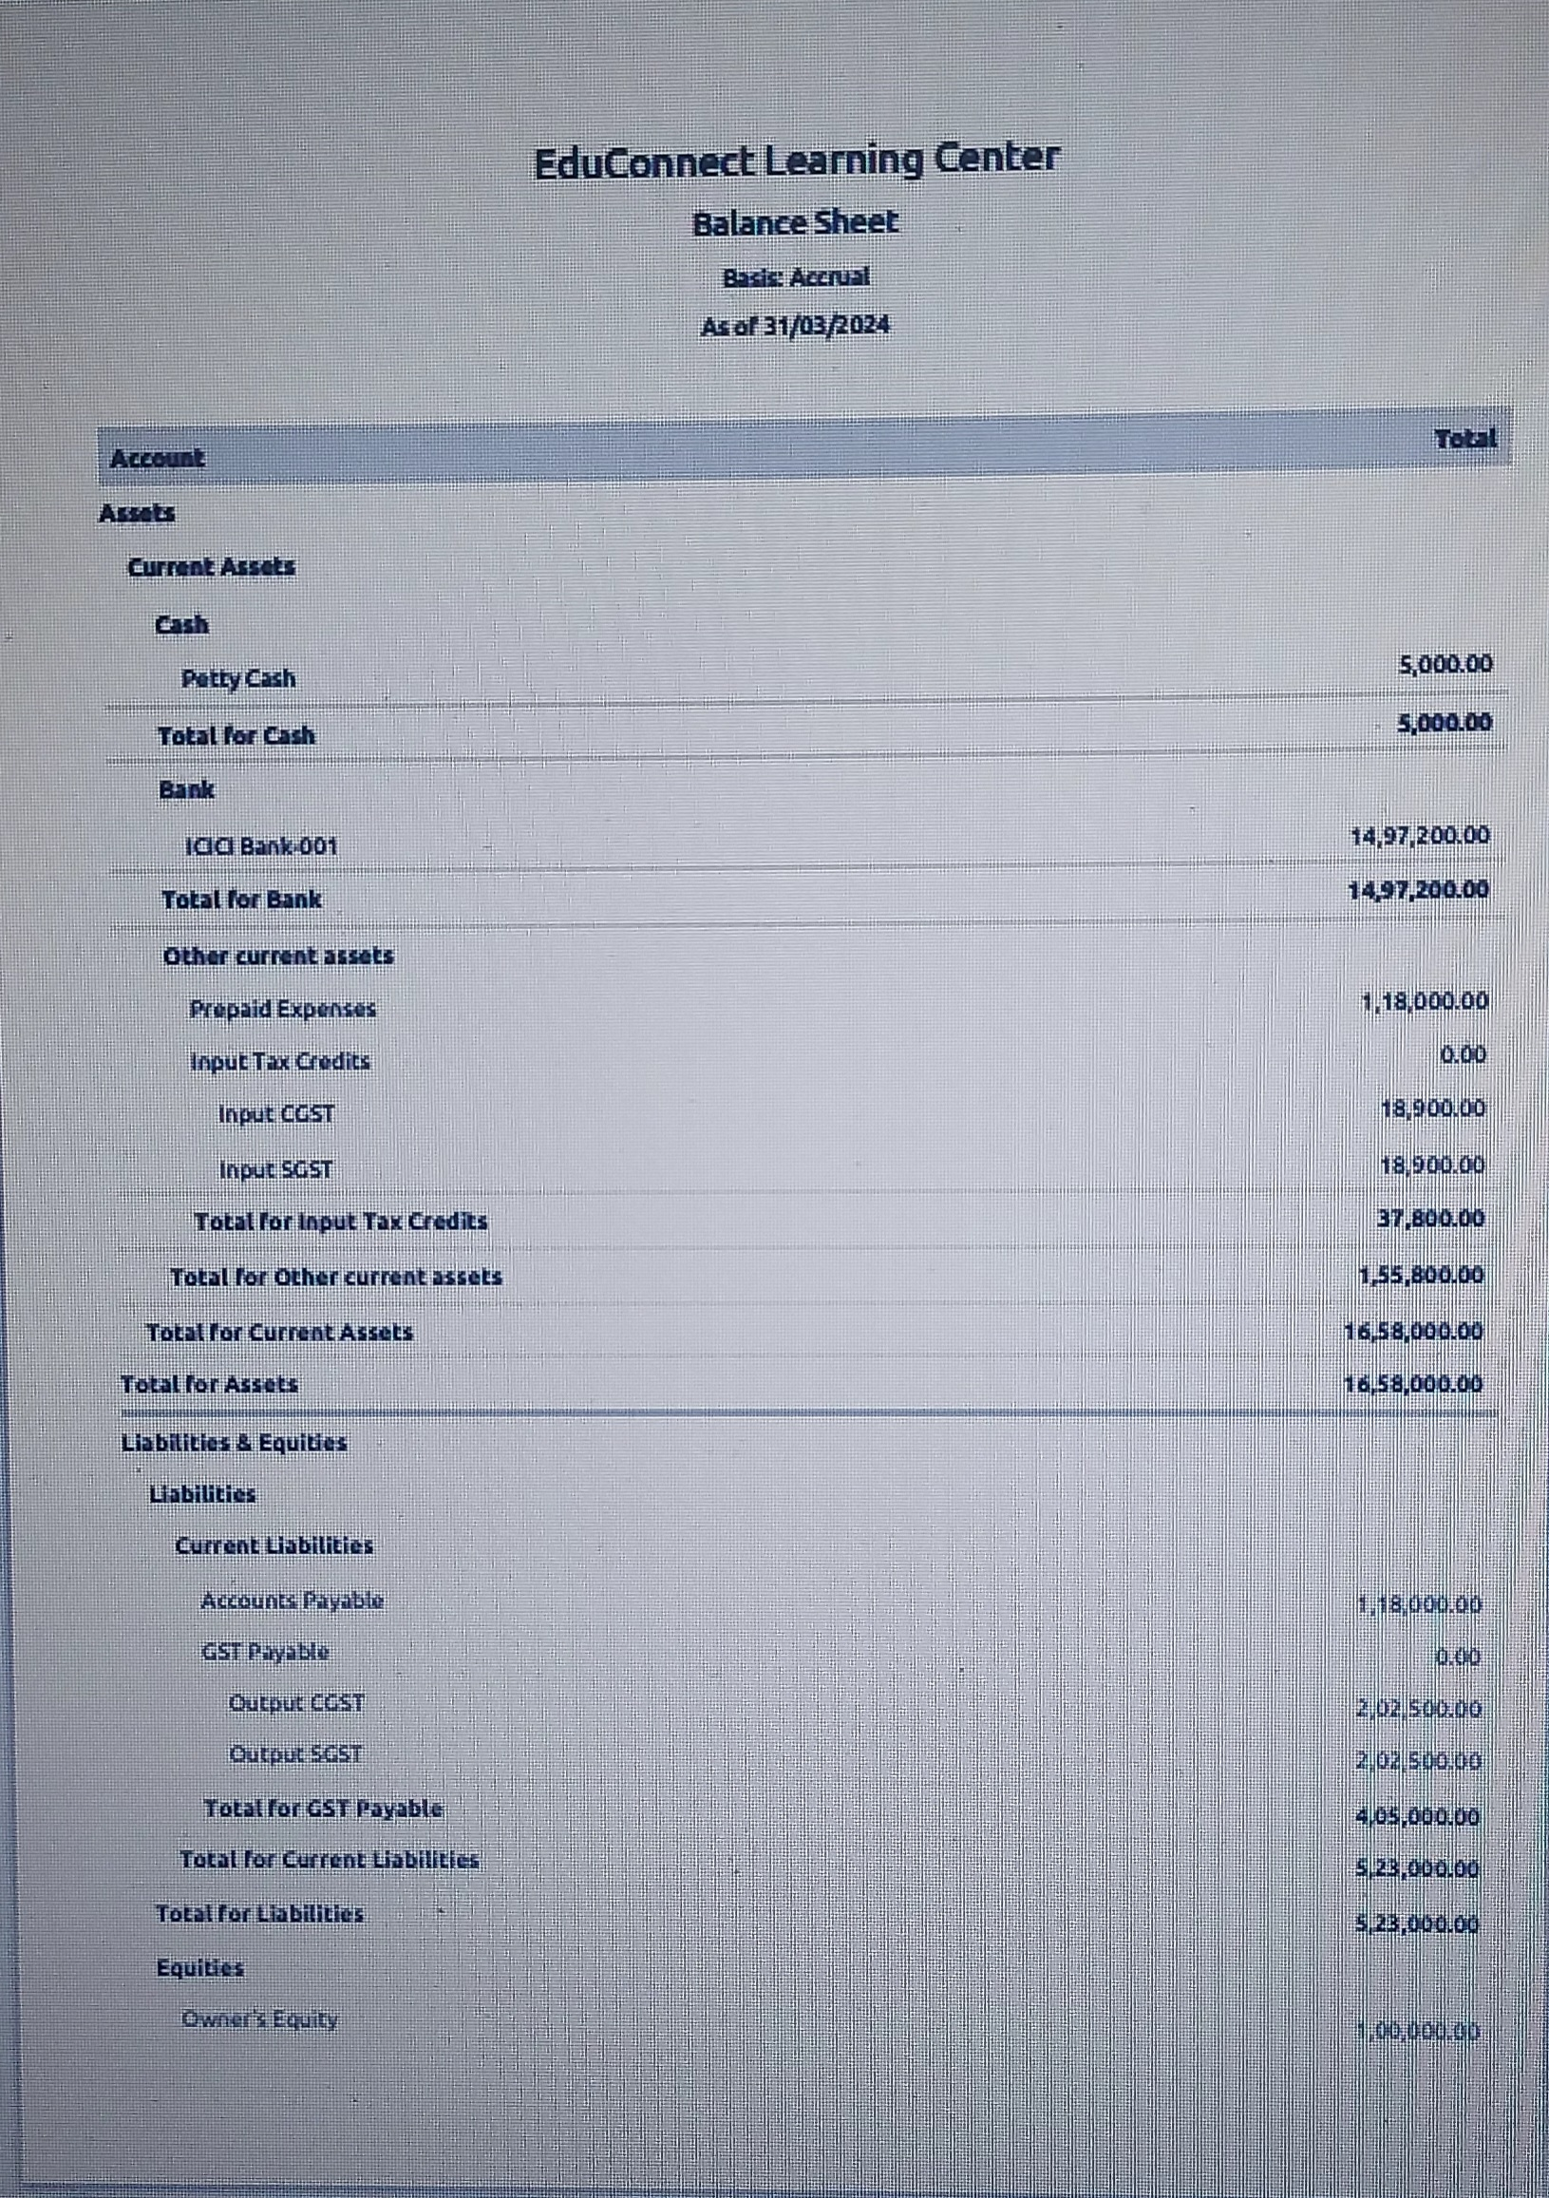

***Edu Connect Learning***

***PROFIT AND LOSS ACCOUNT***

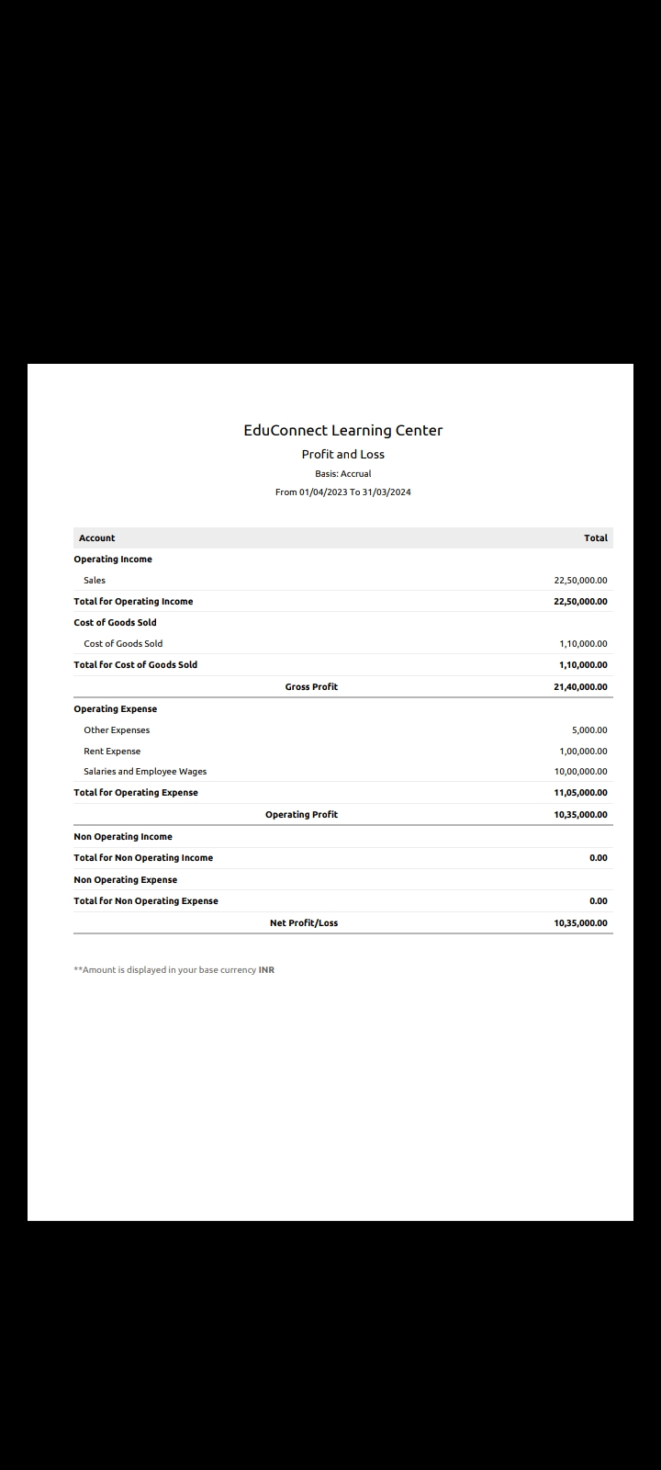

***GSTR-3B SUMMARY***

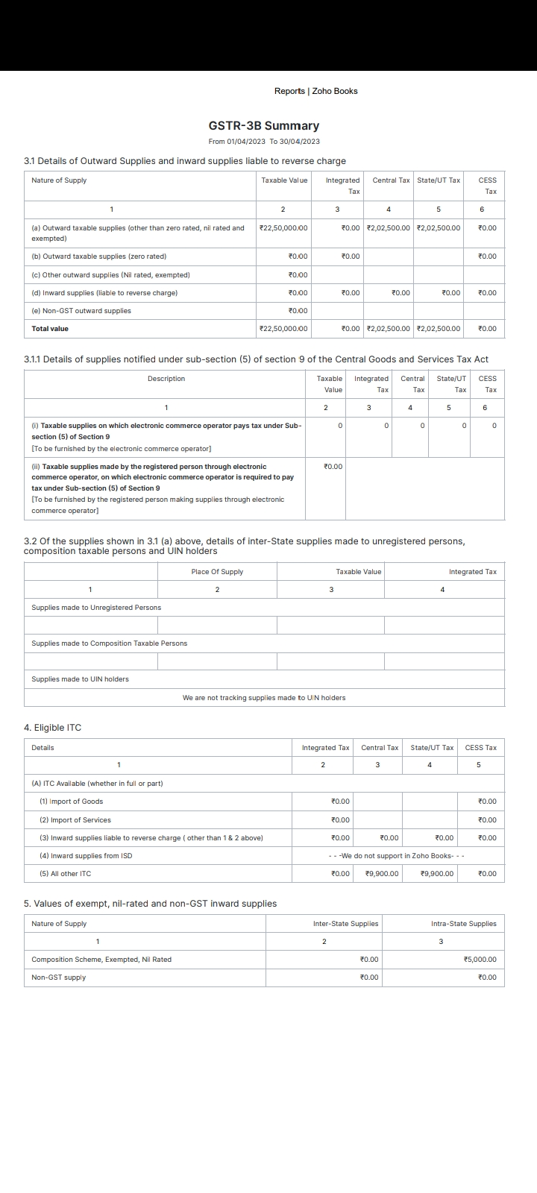

***AR Aging Summary***

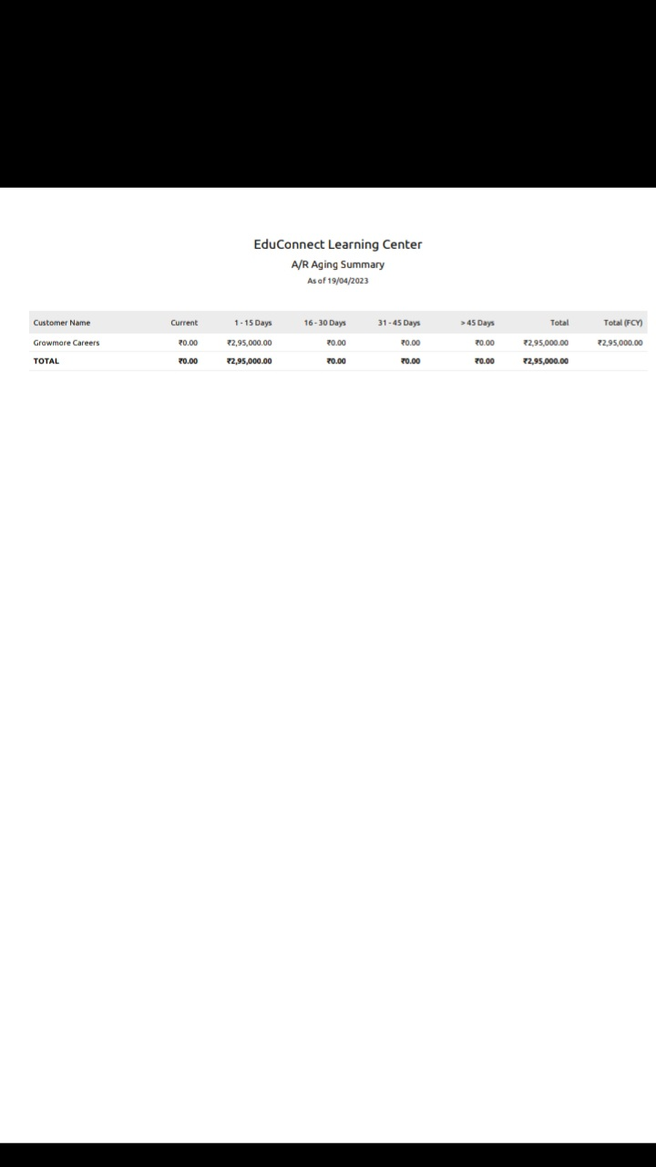

***AP Aging Summary***

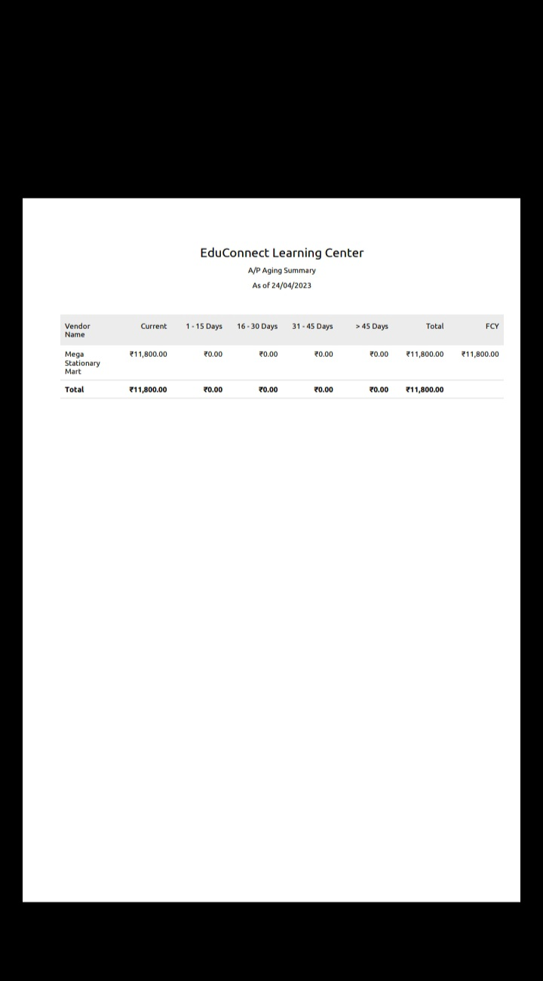

## *Advantage of learning Centre*

Learning centers offer several advantages that contribute to effective and personalized learning experiences. Here are some key advantages of learning centers:

Individualized Learning: Learning centers can tailor their resources and support to the specific needs and pace of each learner, allowing for personalized learning plans.

Flexibility: They often provide flexible schedules and access to materials, accommodating a variety of learning styles and preferences.

Resource Abundance: Learning centers typically have a wide range of educational materials, from books to digital resources, fostering a rich learning environment.

Diverse Learning Opportunities: Learners can access a diverse range of courses, workshops, and resources, enabling them to explore different subjects and skills.

Academic Support: Many learning centers offer tutoring, mentoring, and academic support, assisting learners in achieving their educational goals.

Community and Collaboration: Learning centers can foster a sense of community and encourage collaboration among learners, enhancing the learning experience.

Accessibility: They aim to make education accessible to a broad audience, including individuals with varying abilities and needs.

Skill Development: Learning centers often focus on developing specific skills, helping learners acquire practical and job-related abilities.

Progress Monitoring: They may have mechanisms for tracking and assessing learner progress, allowing for continuous improvement.

Enhanced Motivation: Personalized attention and engaging resources can boost learners' motivation and enthusiasm for learning.

Lifelong Learning: Learning centers support ongoing education, making it possible for individuals to continue learning throughout their lives.

Professional Development: Many learning centers offer opportunities for professionals to enhance their skills and advance their careers.

Cultivation of Critical Thinking: They promote critical thinking and problem-solving skills by encouraging hands-on learning and exploration.

Cultural Enrichment: Learning centers often offer resources related to culture, history, and art, enriching learners' understanding of the world.

Career Advancement: For adults, learning centers can be a pathway to career advancement by providing relevant training and certifications.

Specialized Expertise: Some learning centers focus on specific fields or industries, providing access to specialized knowledge and expertise.

Innovation and Creativity: Learning centers may encourage innovation and creativity by offering opportunities for project-based learning.

Community Engagement: They can foster connections between learners and the local community by partnering with local businesses and organizations.

Preparation for Higher Education: Learning centers can prepare students for further education by providing foundational knowledge and skills.

Life Skills: They can teach essential life skills, such as financial literacy, time management, and communication.

* In summary, learning centers offer a wide range of advantages that support and enhance the learning process for individuals of all ages. These advantages include personalized learning, diverse resources, academic support, community, skill development, and much more, making them valuable educational assets.

***Disadvantage***

While learning centers offer many advantages, they can also have some disadvantages and limitations. Here are some common disadvantages of learning centers:

Limited Access: Not everyone may have easy access to a learning center due to geographical constraints, transportation issues, or financial barriers.

Resource Limitations: Learning centers may have limited resources, especially in terms of specialized equipment, materials, or staff.

Inconsistent Quality: The quality of education and support provided at learning centers can vary widely depending on the center's funding, staff expertise, and organization.

Overcrowding: In some cases, popular learning centers can become overcrowded, making it challenging to provide personalized attention to each learner.

Cost: Even though some learning centers are free, others may require payment, which can be a barrier for those with financial constraints.

Limited Scope: Some learning centers may have a narrow focus, making them unsuitable for individuals seeking a more comprehensive or diverse education.

Dependency on Staff: The effectiveness of a learning center can depend on the skills and dedication of the staff, and turnover can affect consistency.

Lack of Real-World Experience: While learning centers can provide valuable knowledge, they may not always offer opportunities for practical, real-world experience.

Rigid Structure: Some learning centers may have a rigid curriculum or structure that doesn't allow for flexibility or adaptation to individual learning styles.

Inefficiency for Some Learners: For self-directed learners or those who thrive in more independent settings, the structured nature of learning centers may be less effective.

Limited Focus on Soft Skills: Some learning centers may emphasize academic or technical skills but may not provide sufficient attention to critical soft skills, like communication or problem-solving.

Transportation and Scheduling Challenges: Learning centers may not align with the schedules and transportation options of all potential learners.

Lack of Technology Integration: In the digital age, some learning centers may not effectively integrate technology or online resources, potentially limiting access and relevance.

Safety Concerns: In physical learning centers, safety and security issues may arise, especially for younger learners.

Cultural and Language Barriers: Learning centers may not always address the diverse cultural and linguistic needs of the community they serve.

External Distractions: Learning centers may not always provide an environment free from external distractions, making focused learning more challenging.

Waiting Lists: Some high-demand learning centers may have waiting lists, causing delays for learners seeking assistance.

* + It's important to note that the specific disadvantages of learning centers can vary greatly depending on the center's nature, its resources, and the needs and goals of the learners. Addressing these disadvantages often requires careful planning, resource allocation, and a commitment to providing accessible, quality education.

**APPLICATION**

Access Education Center.

Centre of Excellence.

Learner in.

**CONCLUSION**

Me and my team members have completed all the activities in the respective manner.

**FUTURE SCOPE**

Personalized Learning.

Skill Development.

Emerging Technologies.

Therefore the future scope of Edu Connect Learning Centre is relatively very high.